(Неделя 1)

The kind of writing you will do in this class is called academic writing because it is the kind of writing you do in college classes. Every kind of writing has a particular purpose and a particular audience. The purpose of academic writing is to explain something or to give information about something. Its audience is your teacher and your classmates.
Academic writing requires certain skills. These skills include sentence structure (how to arrange words in a sentence), organization (how to arrange ideas in a paragraph), and, of course, grammar and punctuation.

A paragraph is a group of related sentences about a single topic. The topic of a paragraph is one, and only one idea.
A paragraph has three main parts.
- Topic sentence
The first sentence in a paragraph is a sentence that names the topic and tells what the paragraph will explain about the topic. This sentence is called the topic sentence.
- Supporting sentences
The middle sentences in a paragraph are called the supporting sentences. Supporting sentences give examples or other details about the topic.
- Concluding sentence
The last sentence in a paragraph is called the concluding sentence. A concluding sentence often repeats the topic sentence in different words or summarizes the main points.

Each paragraph that you write for this class should also have a title. A title tells the topic of the paragraph in a few words. A title is short. It is not a complete sentence. It may be just one word. Here are some examples of titles.
My Flat
New Gadgets
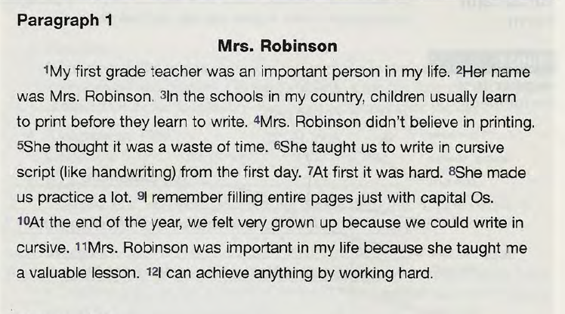

In academic writing, there is a special form for paragraphs.
You should put your name (and group), course number (subject), and date. Your paper should have a title and margins.
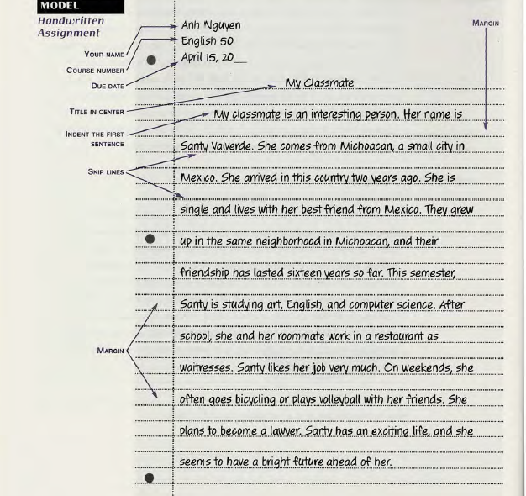

If you use a computer, make your paper look like this:
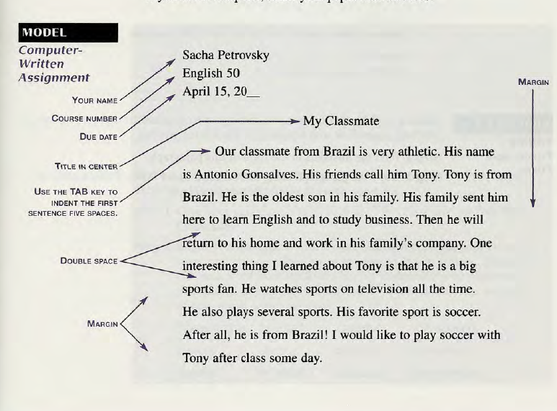

Here are the rules for correct paragraph form for a paragraph typed on a computer.
- Paper
Use standard white paper.
- Font
Use a standard font style, such as Times New Roman. Do not use underlining, italics, or bold type to emphasize words. It is not correct to do so in academic writing.
- Heading
Type your full name in the upper left corner. On the next line, type the course number. On the third line of the heading, type the date the assignment is due in the order month-day-year, with a comma after the day.
- Assignment Title
Skip one line, and then center your title. Use the centering icon on your word processing program.
- Body
Skip one line, and start typing on the third line. Indent (move to the right) the first line of each paragraph by using the TAB key. (The TAB key automatically indents five spaces.)
- Margins
Leave a 1-inch margin on the left and right margins.
- Spacing
Double-space the body.

A sentence is a group of words that contains a subject and a verb and expresses a complete thought. A sentence begins with a capital letter and ends with a period.

These are sentences:
He is a student.
It is hot today.
He looks tired.

These are not sentences:

Is very athletic. (There is no subject.)
The man bought. (This is not a complete thought. What did the man buy?)

Command Sentences
If a sentence gives a command or instruction, we understand that the subject is you, but we don’t say or write you. The verb in a command sentence is always in the simple (dictionary) form—stop, go, wait, be, eat. To make a command negative, put don’t in front of the verb.
Commands Negative Commands

Be quiet. Don’t eat so much!
Wait for me! Don’t forget to call home.
Speak slowly. Don’t worry.

In English, the subject of a sentence is always expressed (except in commands). The subject tells who or what did something. It is a noun or pronoun.

e.g. We came at 6 pm.

The verb usually tells an action. Sometimes a verb doesn’t tell an action. Sometimes it just links the subject with the rest of the sentence.

e.g. We came at 6 pm.

Action verbs name an action, such as hit, live, lose, speak, go, and come.
Linking verbs link the subject with the rest of the sentence. Linking verbs do not have objects. The most common linking verbs are be, become, look, feel, seem, smell, sound, and taste.

e.g. It is late.

The object receives the action of an action verb. It is a noun or pronoun.

e.g. He bought a printer.

To find an object, make a question by putting what after an action verb. (Note: This method for finding objects doesn’t work with linking verbs because linking verbs do not have objects.)

My roommate lost his keys.
(Lost what?—his keys. His keys is an object.)
Not all sentences have objects.
The sun is shining today.
(Is shining what?—not possible. This sentence has no object.)

Certain verbs MUST have objects. Some of these verbs are buy, give, have, like, love, need, own, place, put, spend, and want.
They need some money.
CAPITALIZATION

In English, there are many rules for using capital letters. Here are six important ones.

Rules | Examples
Capitalize:
1. The first word in a sentence. | My neighbor is a mechanic.
2. The pronoun I. | My friends and I often study together.
3. Names of people and their titles.  but not a title without a name.  Exception: A title without a name is sometimes capitalized if it refers to a specific person. | King Charles, Mr. and Mrs. Homer Simpson  He’s a king.  Have you met your math professor?  The President of the United States had dinner with the Emperor of Japan.
4. Nationalities, languages, religions, and ethnic groups. | Swedish  English  Asian  Muslim  Native American
5. Names of school courses with numbers.  Note: Don’t capitalize school subjects except names of nationalities, languages, religions, and college classes with numbers. | Psychology 101  history  Russian history
6. Specific places you could find on a map. | England  the North Pole  Lake Superior  First Street  New York City

